**Task 26**

**📌 GUI container on the Docker  
🔅 Launch a container on docker in GUI mode   
🔅 Run any GUI software on the container.**

**Using RHEL-8 VM**

**Step1:**

Check the ip of vm using ifconfig.

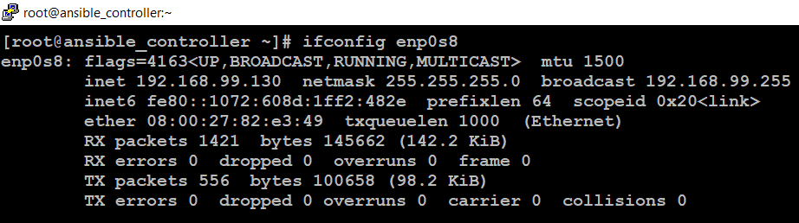

**Step2:** Launching the docker container using centos.

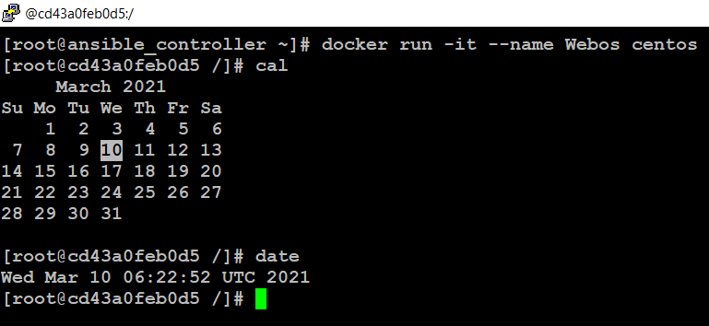

* Check firefox or any GUI software is installed or not.

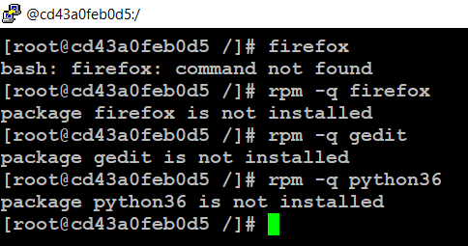

* Install firefox and any other GUI software using yum.

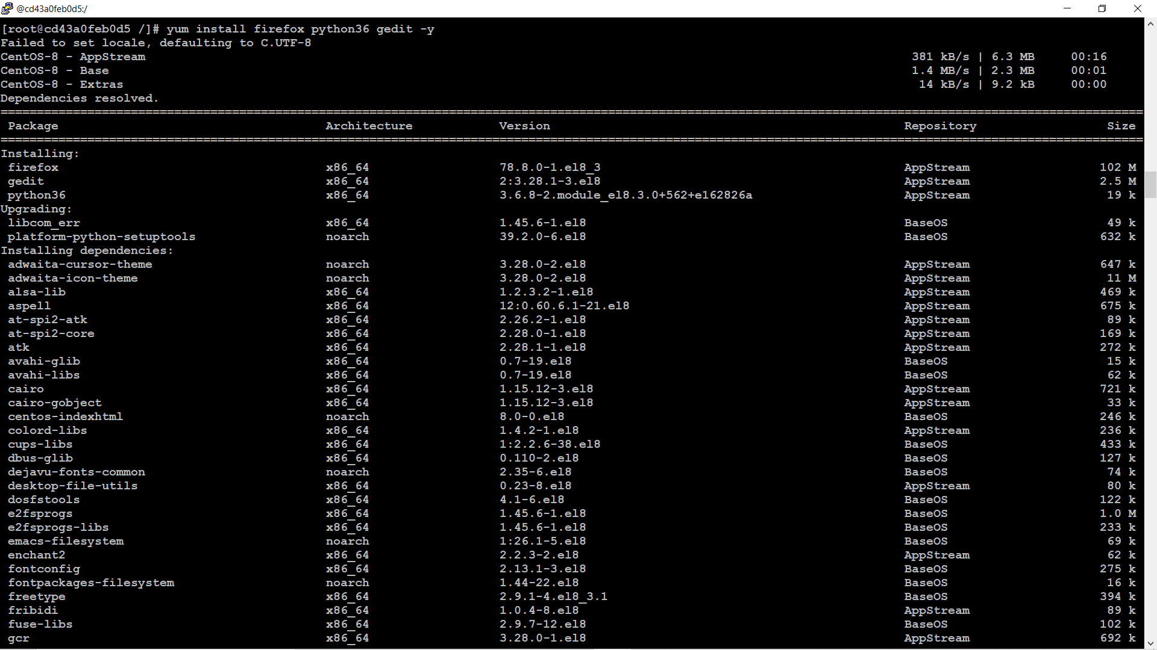

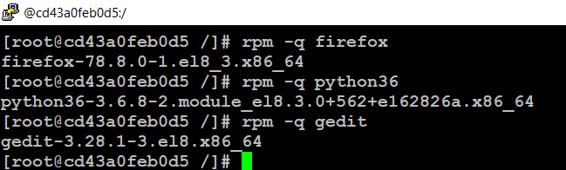

Successfully installed the packages.

**Step3:** Lets open firefox

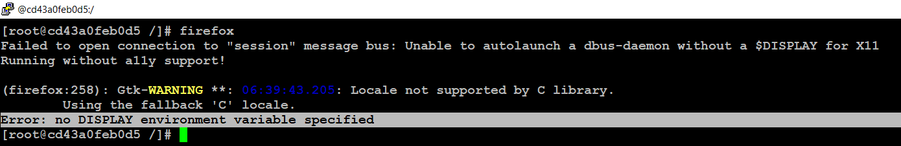

* No display variable specified.

**Step4:** Lets open gedit.

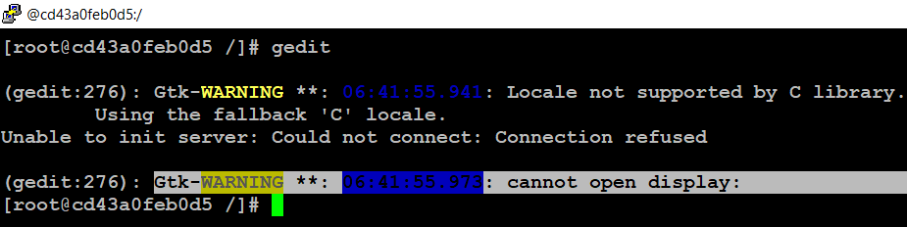

* Can’t open display.
* Warning can be solved by installing **yum install gcc-c++**
* If you face any dbus issue use :

**dbus-uuidgen > /var/lib/dbus/machine-id**

To solve this issue, we need a tool which display graphical linux program.

**What is Xming?**

Xming is an open-source X-Windows terminal emulator (X Server) that runs on Microsoft Windows computers. Xming allows the Windows machines to display a graphical linux program which is basically running on a remote Linux server. Above the basic installation steps, this article demonstrates how to secure an X-Window session using Xming with PuTTY SSH Client.

**Download Xming software at:**

<https://sourceforge.net/projects/xming/>

**step5:** Download and install Xming

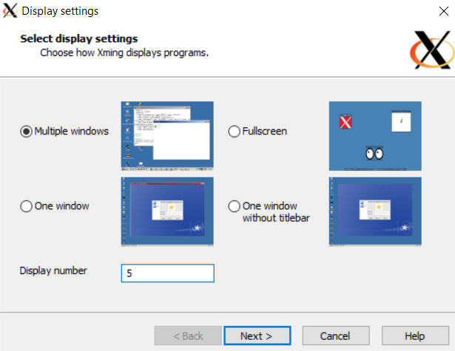

* Here you can give any display number.

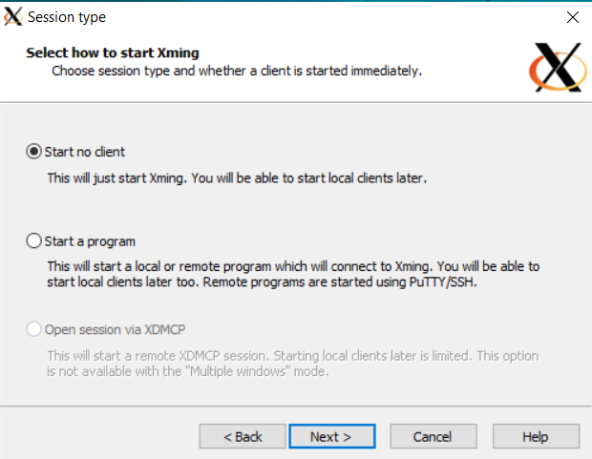

* Enable No Access Control

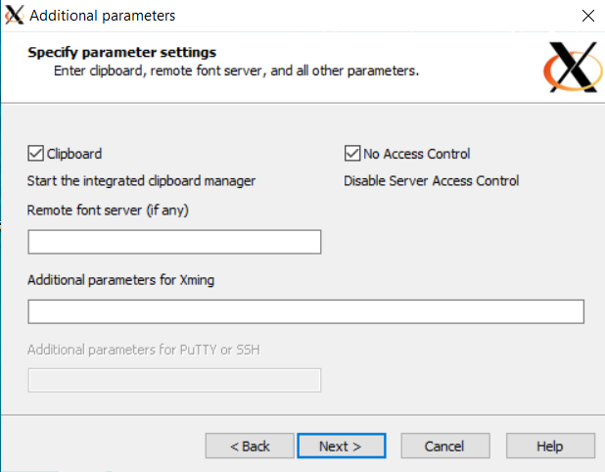

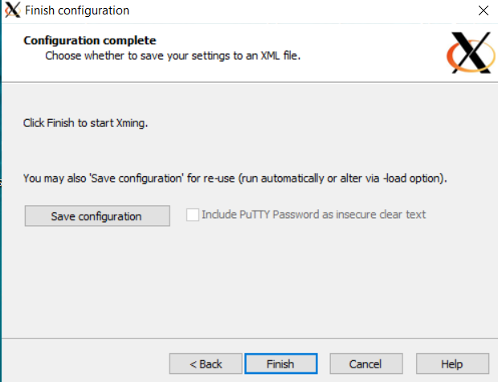

**Step6:** Connect to VM using Putty.

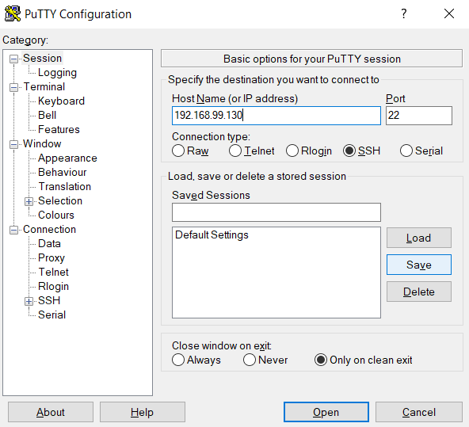

* Enable X11 forwarding

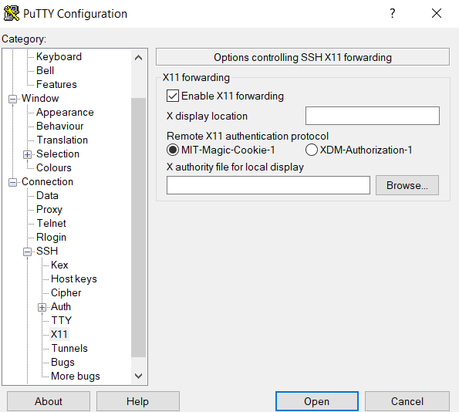

* Login to VM

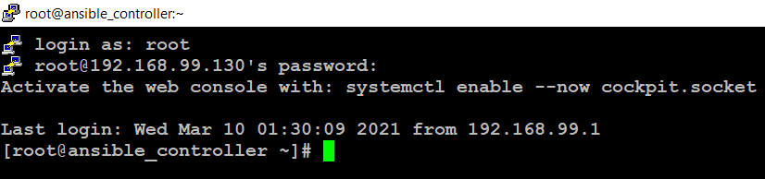

**Step7:** connect to docker container and export Export the display variable.

export DISPLAY=<Windows_Ip>:<Display_Number>

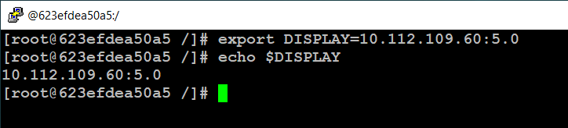

**Step8:** Install some of the Dependency files

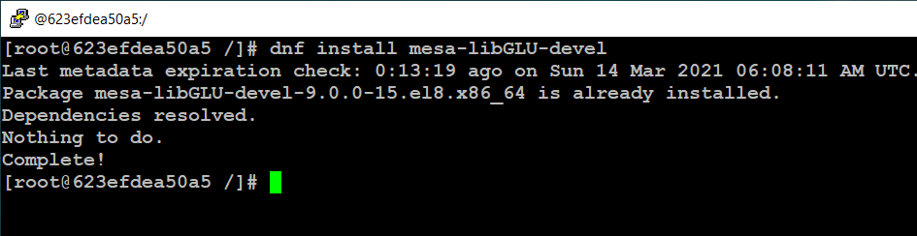

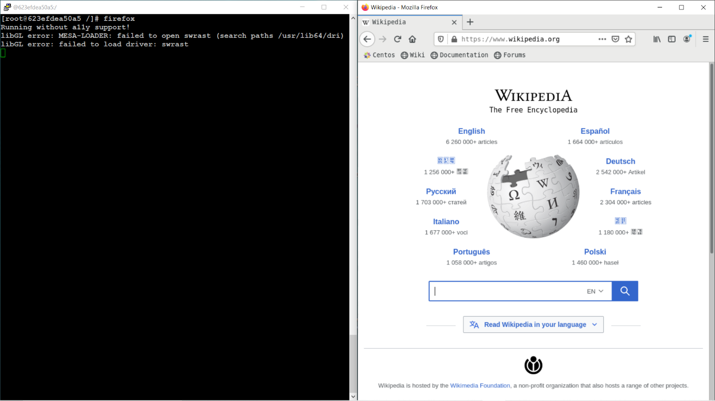

**Step9:** Lets try to use gedit.

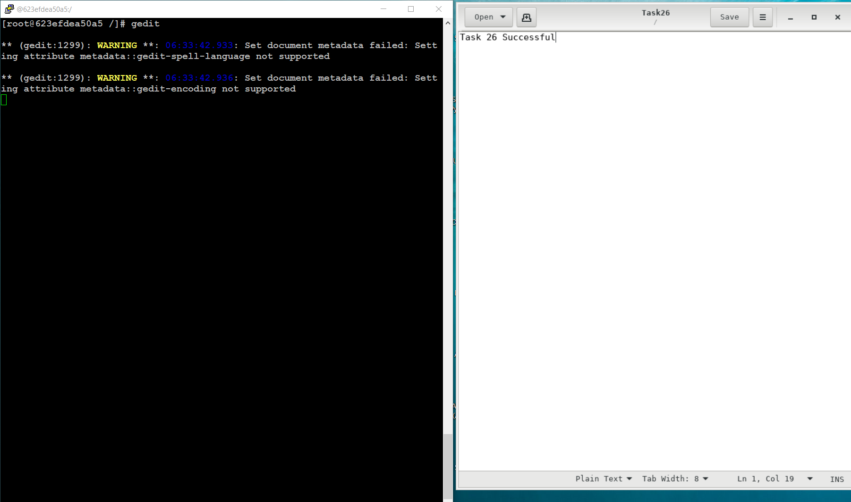

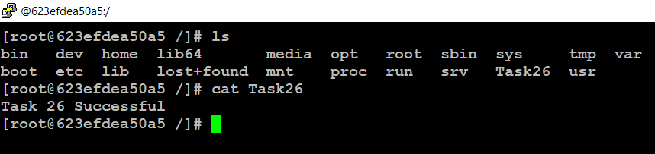

**Thank you**

**GitHub Link: https://github.com/Anuddeeph/Docker_GUI.git**